15 Tools Every Homeowner Should Own
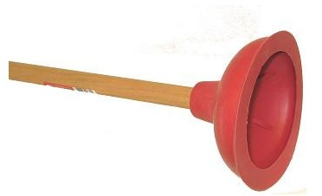
by Nick Gromicko and Ben Gromicko

The following items are essential tools, but this list is by no means exhaustive. Feel free to ask an InterNACHI inspector during your next inspection about other tools that you might find useful.

1. Plunger
A clogged sink or toilet is one of the most inconvenient household problems that you will face. With a plunger on hand, however, you can usually remedy these plumbing issues relatively quickly. It is best to have two plungers -- one for the sink and one for the toilet.

2. Combination Wrench Set
One end of a combination wrench set is open and the other end is a closed loop. Nuts and bolts are manufactured in standard and metric sizes, and because both varieties are widely used, you’ll need both sets of wrenches. For the most control and leverage, always pull the wrench toward you, instead of pushing on it. Also, avoid over-tightening.
3. Slip-Joint Pliers
Use slip-joint pliers to grab hold of a nail, a nut, a bolt, and much more. These types of pliers are versatile because of the jaws, which feature both flat and curved areas for gripping many types of objects. There is also a built-in slip-joint, which allows the user to quickly adjust the jaw size to suit most tasks.
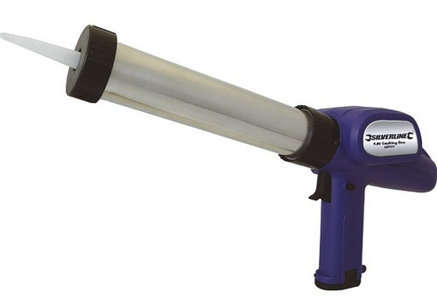
4. Adjustable Wrench
Adjustable wrenches are somewhat awkward to use and can damage a bolt or nut if they are not handled properly. However, adjustable wrenches are ideal for situations where you need two wrenches of the same size. Screw the jaws all the way closed to avoid damaging the bolt or nut.
5. Caulking Gun
Caulking is the process of sealing up cracks and gaps in various structures and certain types of piping. Caulking can provide noise mitigation and thermal insulation, and control water penetration. Caulk should be applied only to areas that are clean and dry.

6. Flashlight
None of the tools in this list is of any use if you cannot visually inspect the situation. The problem, and solution, are apparent only with a good flashlight. A traditional two-battery flashlight is usually sufficient, as larger flashlights may be too unwieldy.

7. Tape Measure
Measuring house projects requires a tape measure -- not a ruler or a yardstick. Tape measures come in many lengths, although 25 feet is best. Measure everything at least twice to ensure accuracy.
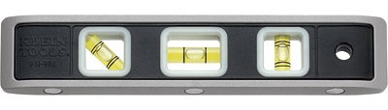
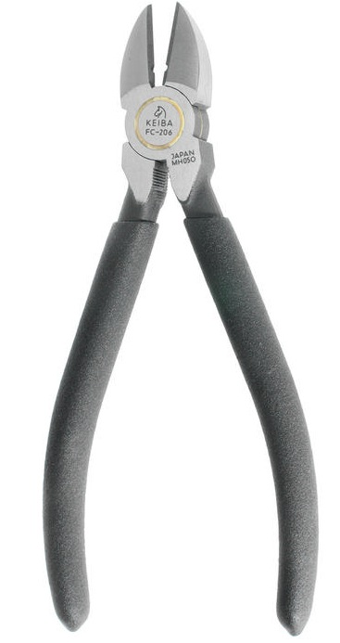
8. Hacksaw
A hacksaw is useful for cutting metal objects, such as pipes, bolts and brackets. Hacksaws look thin and flimsy, but they’ll easily cut through even the hardest of metals. Blades are replaceable, so focus your purchase on a quality hacksaw frame.
9. Torpedo Level
Only a level can be used to determine if something, such as a shelf, appliance or picture, is correctly oriented. The torpedo-style level is unique because it not only shows when an object is perfectly horizontal or vertical, but it also has a gauge that shows when an object is at a 45-degree angle. The bubble in the viewfinder must be exactly in the middle -- not merely close.
10. Safety Glasses / Goggles
For all tasks involving a hammer or a power tool, you should always wear safety glasses or goggles. They should also be worn while you mix chemicals.
11. Claw Hammer
A good hammer is one of the most important tools you can own. Use it to drive and remove nails, to pry wood loose from the house, and in combination with other tools. They come in a variety of sizes, although a 16-ounce hammer is the best all-purpose choice.
12. Screwdriver Set
It is best to have four screwdrivers: a small and large version of both a flathead and a Phillips-head screwdriver. Electrical screwdrivers are sometimes convenient, but they're no substitute. Manual screwdrivers can reach into more places and they are less likely to damage the screw.
13. Wire Cutters
Wire cutters are pliers designed to cut wires and small nails. The side-cutting style (unlike the stronger end-cutting style) is handy, but not strong enough to cut small nails.
14. Respirator / Safety Mask
While paints and other coatings are now manufactured to be less toxic (and lead-free) than in previous decades, most still contain dangerous chemicals, which is why you should wear a mask to avoid accidentally inhaling. A mask should also be worn when working in dusty and dirty environments. Disposable masks usually come in packs of 10 and should be thrown away after use. Full and half-face respirators can be used to prevent the inhalation of very fine particles that ordinary facemasks will not stop.
15. Duct Tape
This tape is extremely strong and adaptable. Originally, it was widely used to make temporary repairs to many types of military equipment. Today, it’s one of the key items specified for home emergency kits because it is water-resistant and extremely sticky.

